**Excel Assignment – 6**

**1. What are the various elements of the Excel interface? Describe how**

**they're used.**

* The Excel interface consists of several elements that provide users with tools and features to create, edit, and analyze data. Here are the main elements and their funcations:

1. Title Bar: The title bar displays the name of the current workbook and includes options to minimize, maximize or close the Excel window.
2. Ribbon :The ribbon is located below the title bar and is divided into tabs, each containing group of related commands. The tabs vary depending on the version of excel, but common tabs include Home, Insert, Formulas, Data, Review and View.
3. Quick Access Toolbar: This customizable toolbar is located above the ribbon or below the title bar and allow you to add frequently used commands for quick access.
4. File Menu: Clicking the file tab on the ribbon open the Backstage view, which provides options for managing file and accessing Excel settings.
5. Worksheet: Excel workbooks consist of multiple worksheet that allow you to organize and work with the different set of data within the same file.
6. Column and Rows: Column are identified by letters and rows are identified by numbers. These form a grid pattern and interest to created cells where data is entered.
7. Formula Bar: The formula bar is located above the worksheet grid and displays the contents of the active cell. You can enter and edit formulas directly in the formula bar to perform calculations and manipulate data.
8. Name Box: The Name box is located next to the formula bar and displays the cell reference or name of the active cell. You can manually enter cell reference or use it to navigate to specific cells in the worksheet.
9. Status bar: The status bar is located at the bottom of the Excel window and provides information about the current status of the workbook. It displays the sum, average, count ,and other calculations for selected cells, as well as indicators for featured like caps locks, num lock and scroll lock.

**2.Write down the various applications of Excel in the industry.**

-Application of Excel in the different industries as follows:

1. Finance and Accounting: Excel is extensively used for financial modeling, budjenting, and forcasting. It enables professional to track expenses, create financial statements, analyze cash flow, manage investments, perform cost analysis and generate financial reports.

2. Sales and Marketing: Excel helps in managing sales data, analyzing customers trends, creating sales forecasts and tracking marketing campaigns. It is used for customer relationship management (CRM), Lead management, data visualization, market research analysis. Creating sales report.

3. Human Resources: Excel is utilized for HR functions such as employee data management, payroll calculations, attendee tracking, performance evaluation and employee scheduling.

4. Project Management: Excel serves as a valuable tool for project planning , task tracking, and progress monitoring. It can be used for creating Gatt charts, project timelines resource allocation, budgeting, risk management.

5. Data Analysis and Reporting : Excel offers robust data analysis capabilities, including functions, formulas, and data visualization tools. It is used for data cleaning, sorting, filtering, pivot tables, statistical analysis, regression analysis and creating insightful charts and graphs.

6. Supply chain and Logistics: Excel assists in inventory management , supply chain optimization, demand forecasting ,order tracking, and logistics planning. It helps professionals streamline processes, analyze supplier performance, track shipments and manage warehouse operations.

7. Research and Academia: Excel is widely used in research and academia for data collection, data analysis, and statistical modeling. It aids in organizing research data , conducting surveys, running statistical tests, creating charts and graphs, and presenting research findings.

8. Engineering and Manufacturing: Excel supports engineering calculations, product costing, quality control analysis, and process optimization. It is used to perform engineering calculations, design experiments, analyze production data .

9. Healthcare and Pharmaceuticals: Excel finds applications in healthcare for patient data management, medical records analysis, clinical research and financial analysis.

10. Edcation and Training : Excel is utilized in educational institutions for lesson planning, grade tracking, student data analysis and educational research. It enables teachers to create interactive worksheets, mange student records, analyze performance and generate progress reports.

**3. On the ribbon, make a new tab. Add some different groups, insert**

**commands in the groups and name them according to their commands**

**added. Copy and paste the screenshot of the steps you followed.**

- steps to create a new tab, add groups, and insert commands in Excel ribbon.

1. Open Excel and Click on the “File”tab located on the top-left corner of the Excel window.

2. From the menu,click on “Options” This will open the Excel Options dialog box.

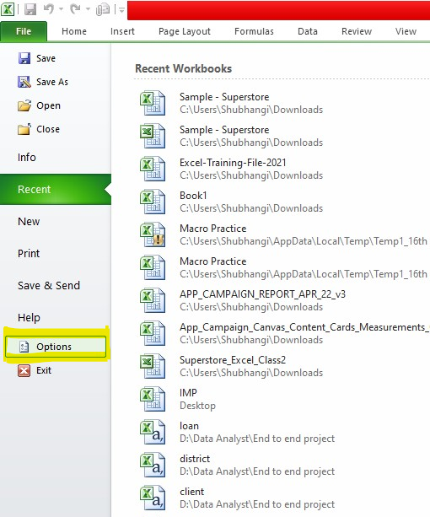

3. In the Excel options dialog box, select the “Customize Ribbon” option from the left sidebar.

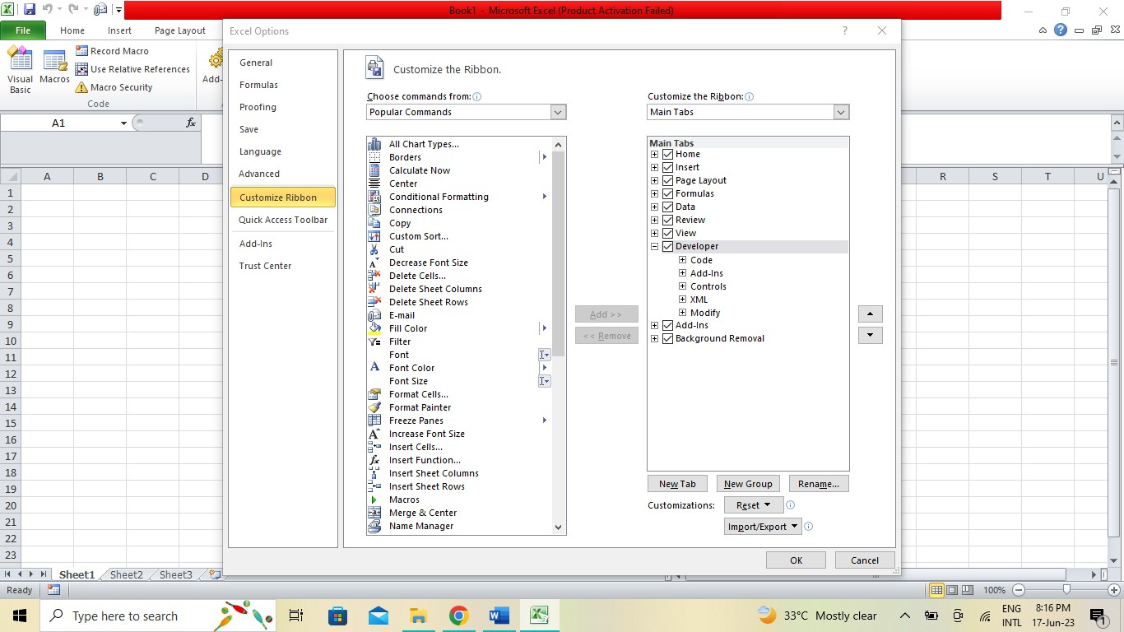

4. On the right side, under the “Customize the Ribbon” section, click on the “New Tab” button.

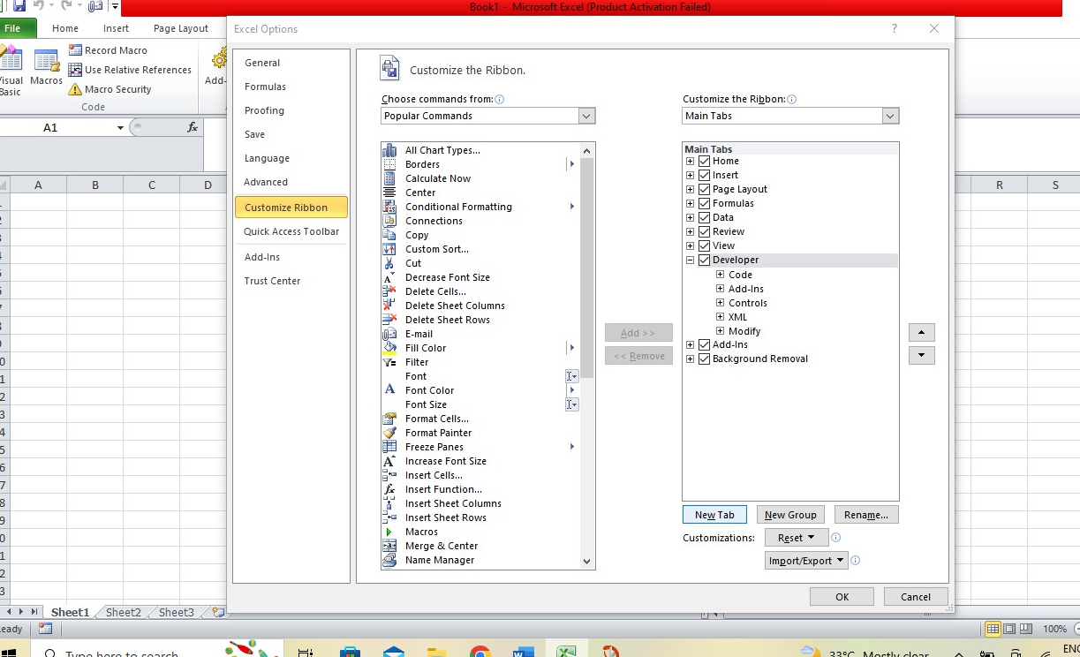

5. With the new tab selected, click on the “Rename” button below the list. Enter name for your new tab. For example, you can name it “New SS_Custom Tab”.

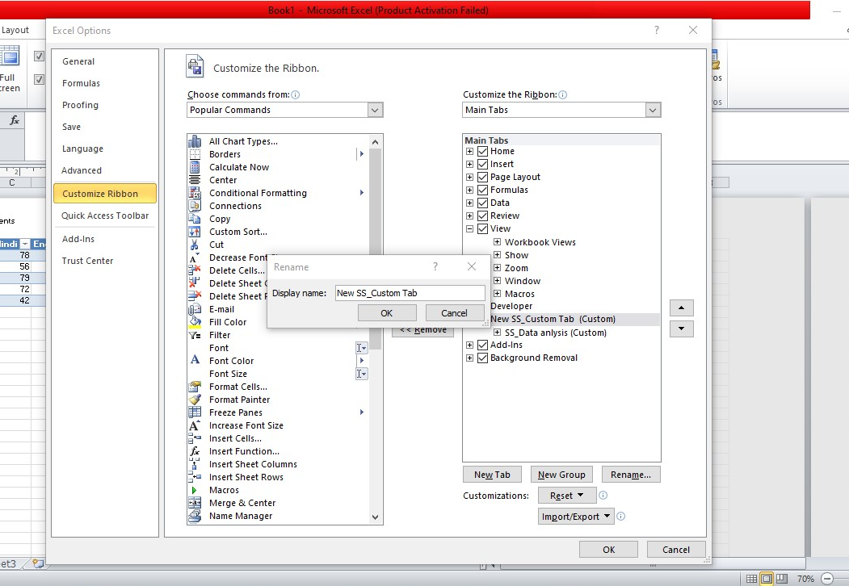

6. With the new tab still selected, click on the “New Group” button below the list. This will create a new group under the selected tab.

7. With the new group selected, click on the “Choose commands from” drop-down menu above the list and select the category of commands you want to add.

8. With the new group selected, click on the “Choose commands from” drop-down menu above the list and select the category of commands you want to add. For instance, you can select “Formulas” to add formula-related commands.

9. From the left list, select the command you want to add to the group, and then click on the “Add” button to move it to the new group. Repeat this step for each command you want to add.

10. Click on the “Ok” button to save the changes and close the excel dialog box.

**4. Make a list of different shortcut keys that are only connected to**

**formatting with their functions.**

* Here is a list of some common formatting shortcut keys in Excel and their funcations:

1. Ctrl + B: Bold – Applies or remove bold formatting to the selected cells or text.
2. Ctrl + I : ltalic – Applies or remove italic formatting to the selected cells or text.
3. Ctrl + U: Underline – Applies or remove underline formatting to the selected cells or text.
4. Ctrl+Shift+F: Font – Displays the format cells dialog box with the font tab selected allowing you to modify font styles,size, and effects.
5. Ctrl+Shift+P: Point size: Increases the font size of the selected cells or text.
6. Ctrl+Shift+F1: Format cells: Displays the format cells dialog box,allowing you to modify various formatting options, such as number format, alignment, borders and more.
7. Ctrl + 1: Format Cells- Open the format cells dialog box directly, allowing you to modify various formatting options without navigating through the ribbon.
8. Ctrl+shift+ ~: General format- Applies the General number format to the selected cells, removing any existing formatting.
9. Ctrl+Shift+$: Current format -Applies the currency number format to the selected cells.
10. Ctrl+shift+%: Percentage format- Applies the percentage number format to the selected cells.
11. Ctrl+Shift+#: Date format- Applies the date number format to the selected cells.
12. Ctrl+shift+@: Time format: Applies the time number format to the selected cells.
13. Ctrl+Shift+!: Comma format- Applies the comma number format to the selected cells, displaying thousands separators.
14. Ctrl+Shift+^: Exponential format- Applies the Exponential number format to the selected cells.
15. Ctrl+ Shift+_: Remove borders- Remove borders from the selected cells.
16. Alt+H+B: Bottom border- Applies or remove a bottom border to the selected cells.
17. Alt+H+J : Justify-Appliers justified alignment to the selected cells, spreading the text evenly across the cell width.
18. Alt+H+A+C: Clear- clears formatting from the selected cells.

**5. What distinguishes Excel from other analytical tools?**

1. User- friendly Interface: Excel has a user-friendly interface with a familiar spreadsheet layout, making it accessible to users of all skill levels. Its intuitive grid-based structure and easy to use formulas and funcation make it widely adopted and suitable for various industries and applications.

2.Versatility: Excel is a versatile tool that combines basic data entry and manipulation with powerful analytical capabilities, It allows users to perform calculations, create charts and graphs, conduct data analysis, build models, generate reports.

3. Wide Adoption: Excel has been around for several decades and has a vast user base. It is widely used across industries, making it a standard tool for data analysis and reporting.

4.Formuls and funcations: Excel offer a vast library of built-in-formulas and funactions that enables users to perform complex calculations and automate repetitive tasks. From simple arithmetic operation to advanced statistical analysis and financial modeling.

5. Data Visualization: Excel to provide robust tools for data visualization, user to create a wide range of charts, graphs, and visual representation of their data.

**6. Create a table and add a custom header and footer to your table.**

- 1. Open Excel and create a new workbook or open and exiting one. Enter your data in the desired columns and row to create a table . You can select the data range and press Ctrl+T to quickly convert into a table.

2. With the table selected, navigate to the “Table design”tab that appears when you have a table active.

3. In the “Table Styles” group, you can choose a pre-designed table to apply to your table.

4. To add a custom header, click on the “”Header Row”checkbox in the “Table style options” group. This will format the first row of your table as header row, distinguishing it from the rest of the data.

5.To add a custom footer,click on the “Total Row ”checkboc in the “Table style options” group.

6. Customize the header and footer by clicking on the “Design” tab that appears when you have the table selected.

